3D bioprinting of nerve cells

BY KARTHIK RAVEENDRAN ON JUNE 22, 2015
Imagine a 3D printer which looks like an old school hydraulics and plastics, but prints human organs! The future of printing has come, to take its first few steps to print organs in full flesh.
Researchers at Michigan Technological University hope to use this newly acquired 3D bioprinter to make synthesized nerve tissue. The nanotechnology-inspired material could help regenerate damaged nerves for patients with spinal cord injuries says Tolou Shokuhfar, an Assistant Professor of Mechanical Engineering and Biomedical Engineering at Michigan Tech. Shokuhfar collaborates with Reza Shahbazian-Yassar, the Richard and Elizabeth Henes Associate Professor in the Department of Mechanical Engineering-Engineering Mechanics at Michigan Tech. Shahbazian-Yassar’s highly interdisciplinary background on cellulose nanocrystals as biomaterials, funded by the National Science Foundation’s (NSF) Biomaterials Program, helped inspire the lab’s new 3D printing research.
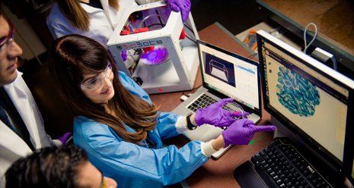
Tolou Shokuhfar and colleagues are developing techniques using 3D bioprinting to generate human tissue
According to Shokuhfar, a human body is born with all the necessary nerve cells it will ever have and healing the damaged nerve cells is very difficult. So, printing such organs becomes a crucial exercise. The key is developing the right “bioink” or printable tissue. Cellulose nanocrystals with extremely good mechanical properties are highly desirable for bioprinting of scaffolds that can be used for live tissues. While most of the other labs address this by using room sized machines and dedicated facilities, the use of 3D printing technology has made the printing of smaller tissues simpler and tabletop work.
“We can pursue nerve regeneration research with a simpler printer set-up,” says Shayan Shafiee, a PhD student working with Shokuhfar.
The small grey box, which is the printer, has inside a red box the plastic casing and a large syringe holding a red jelly-like fluid. Shafiee replenishes the needle-tipped printer, pulls up his laptop and, with a hydraulic whoosh, he starts to print a tissue scaffold.
At his lab bench in the nanotechnology lab at Michigan Tech, Shafiee holds up a petri dish. Inside is what looks like a red gummy candy, about the size of a half-dollar. “This is based on fractal geometry,” Shafiee explains, pointing out the small crenulations and holes pockmarking the jelly. “These are similar to our vertebrae—the idea is to let a nerve pass through the holes.”
Making the tissue compatible with nerve cells begins long before the printer starts up. Shafiee says the first step is to synthesize a biocompatible polymer that is syrupy—but not too thick—that can be printed. That means Shafiee and Shokuhfar have to create their own materials to print with. Nerves don’t just need a biocompatible tissue to act as a carrier for the cells. Nerve function is all about electric pulses. This is where Shokuhfar’s nanotechnology research comes in: Last year, she was awarded a CAREER grant from NSF for her work using graphene in biomaterials research. “Graphene is a wonder material,” she says. “And it has very good electrical conductivity properties.”
She adds that although bioprinting is widespread in the medical field, it is probably a decade or two away from an actual commercial use. In her lab, the future sits on a tabletop in a little gray box!

